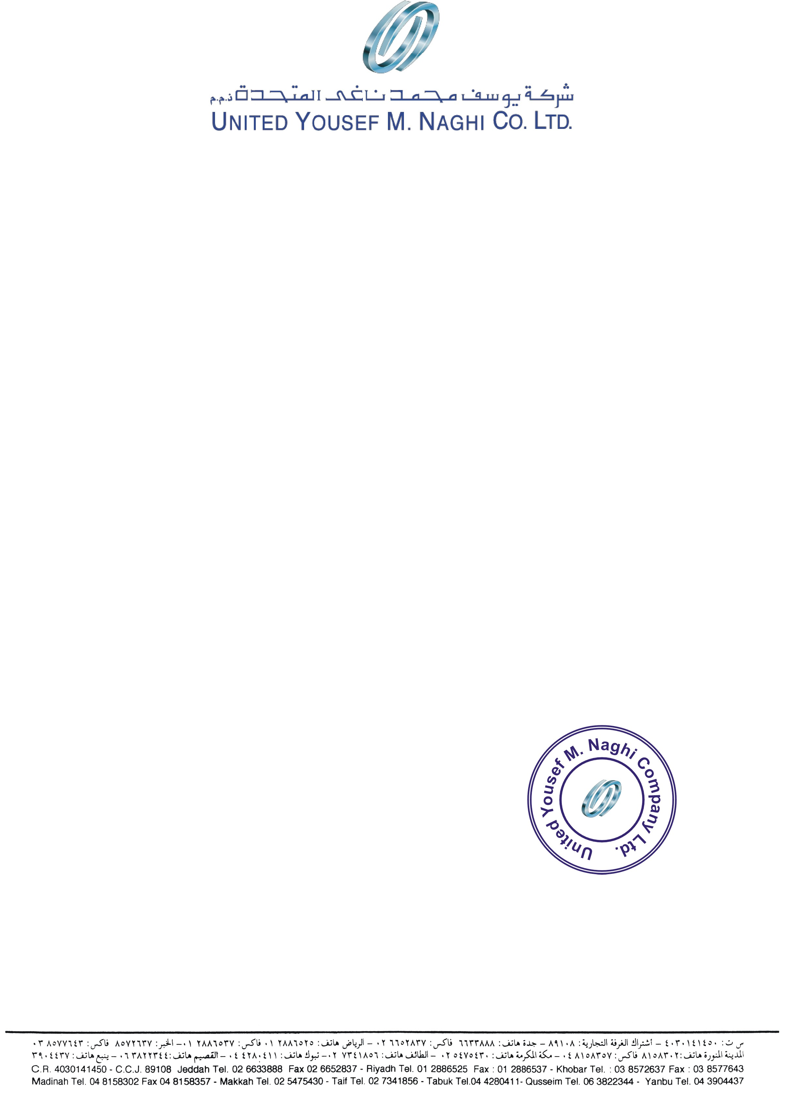

Date: <To>

**TO WHOM IT MAY CONCERN**

We certify that Mr. <Name> <fname> holder of Pakistani Passport No. <Passport> had been employed by this company in the capacity of <Designation> from <From> to <To>.

During his services period we found him hardworking intelligent and having vast experience in this field.

He left the services on his own accord.

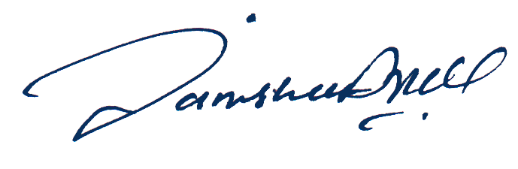

For and on behalf of

United Yousef M. Naghi Co. Lted.

**نبیل عبد العزیز رفہ**

**Mr. Nabeel A. Raffa**

Director Cooperate Affair